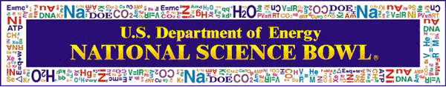

Connecticut Regional Middle School Science Bowl

DATE: Saturday, February 25, 2017
TIME: Registration 8:00AM – 8:20AM
Ends 2:30PM – 6:00PM (based on how team progresses in the afternoon rounds)
WHERE: UConn’s Storrs Campus | Registration: ITE Building Lobby | Event Rounds: Oak Hall
MORE INFORMATION: www.mssb.uconn.edu (event information will also be emailed to coaches)

Code of Conduct
The Department of Energy expects team members, including coaches, to conduct themselves professionally and in a manner that will bring honor to them, their school, and the competition. This is a team event and therefore one team member, by his or her conduct, could jeopardize the entire team. If complaints are received from volunteers, other teams, coordinators, etc. regarding egregious behavior of team members, coaches, or team supporters, the team may be disqualified from the competition.

Use of Electronic Devices
The use of electronic devices (cell phones, MP3 players, iPads/tablets, etc.) is not permitted during any of the competition sessions of the Science Bowl by any student, coach, spectator, or official (except officials in their MSSB official capacity). If a Science Bowl staff member or an official sees a participant using these devices during the prohibited usage periods, the device may be confiscated from the individual and returned at the conclusion of the event. Note: this means NO cell phones may be used in ANY competition room at ANY time.

Agreement
I have read and will abide by the Connecticut Middle School Regional Science Bowl Code of Conduct. Failure to adhere to the items above may result in the disqualification of the team for the 2017 competition.

School Name

Print Student Name Student Signature

Print Parent or Guardian Name Parent or Guardian Signature

Print Coach Name Coach Signature

NOTE: Each team member, his or her parent/guardian, and coach must sign this form in order for the team to participate in the 2017 Connecticut Regional Science Bowl.

Coaches, please return all completed forms in one batch by Friday, January 27, 2017 to:
Email: mssb@uconn.edu (preferred) OR
Mail: Ashley Orcutt
55 North Eagleville Road, U-3060
Storrs, CT 06269-3060

